**Overview**

* **Service Name:** Employee Dashboard
* **Upgrade Date:** 1 July 2025
* **Performed By:** Parvesh Mishra NUDM Team

**Supporting Evidence of Curl Request**

curl --location 'http://localhost:8089/employee-dashboard/_search?_=1751263784242' \

--header 'accept: application/json, text/plain, */*' \

--header 'accept-language: en-US,en;q=0.9,hi;q=0.8' \

--header 'content-type: application/json;charset=UTF-8' \

--header 'origin: https://niuatt.niua.in' \

--header 'priority: u=1, i' \

--header 'referer: https://niuatt.niua.in/digit-ui/employee' \

--header 'sec-ch-ua: "Not(A:Brand";v="99", "Google Chrome";v="133", "Chromium";v="133"' \

--header 'sec-ch-ua-mobile: ?0' \

--header 'sec-ch-ua-platform: "macOS"' \

--header 'sec-fetch-dest: empty' \

--header 'sec-fetch-mode: cors' \

--header 'sec-fetch-site: same-origin' \

--header 'user-agent: Mozilla/5.0 (Macintosh; Intel Mac OS X 10_15_7) AppleWebKit/537.36 (KHTML, like Gecko) Chrome/133.0.0.0 Safari/537.36' \

--data '{

"tenantId": "pg.citya",

"moduleName": "ALL",

"RequestInfo": {

"apiId": "Rainmaker",

"authToken": "1617a04d-2191-45dd-9c82-9564a17766f5",

"userInfo": {

"id": 902,

"uuid": "d1576567-a084-4c36-b49b-332d29c7561e",

"userName": "SV_EMP",

"name": "TVC Employee",

"mobileNumber": "9879879879",

"emailId": null,

"locale": null,

"type": "EMPLOYEE",

"roles": [

{

"name": "Dashboard Employee",

"code": "DASHBOARD_EMPLOYEE",

"tenantId": "pg.citya"

},

{

"name": "TVC Employee",

"code": "TVCEMPLOYEE",

"tenantId": "pg.citya"

},

{

"name": "SV CEMP ",

"code": "SVCEMP",

"tenantId": "pg.citya"

}

],

"active": true,

"tenantId": "pg.citya",

"permanentCity": null

},

"msgId": "1751263784242|en_IN",

"plainAccessRequest": {}

}

}'

**Response**

{

"responseInfo": {

"apiId": "Rainmaker",

"ver": null,

"ts": null,

"resMsgId": "Data Fetched Successfully",

"msgId": "1751263784242|en_IN",

"status": "SUCCESSFUL"

},

"employeeDashboard": {

"applicationReceived": 2426,

"applicationPending": 783,

"applicationApproved": 0,

"totalAmount": 6769037

}

}

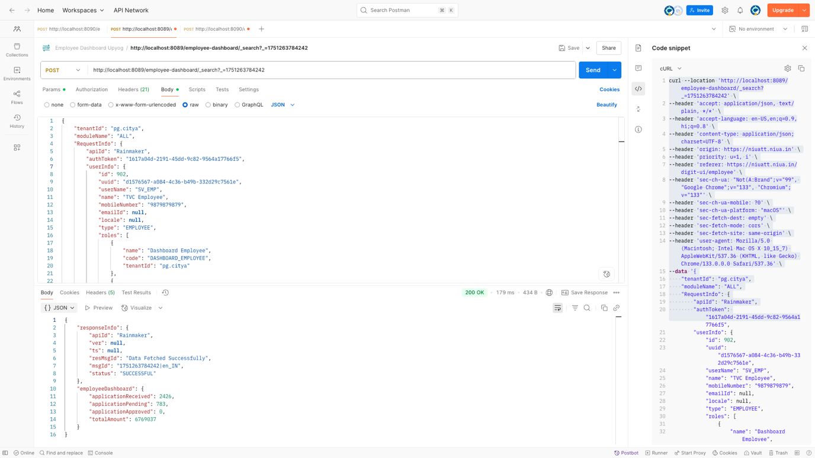

Supporting Evidence: Curl Comparison (Local vs. NIUA Environment)

Supporting Evidence for ALL SERVICES curl

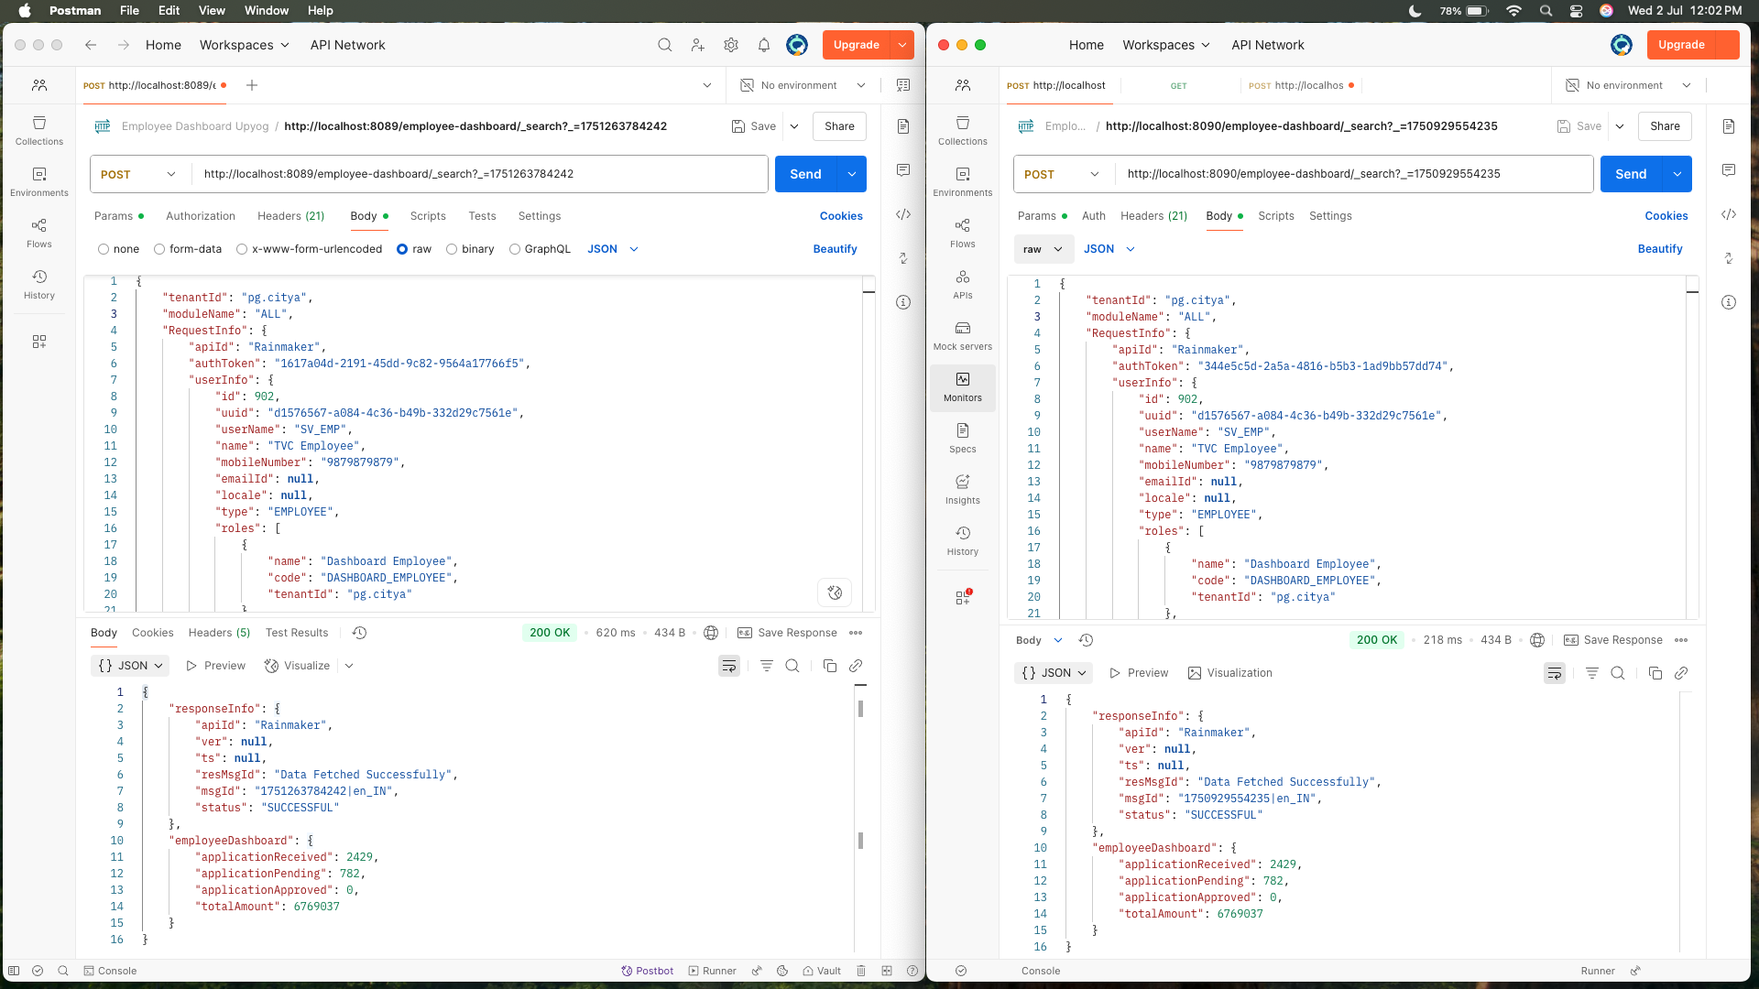

**Note: localhost:8089 is locally & localhost:8090 is niuatt environment for All services**

Response Difference of All services

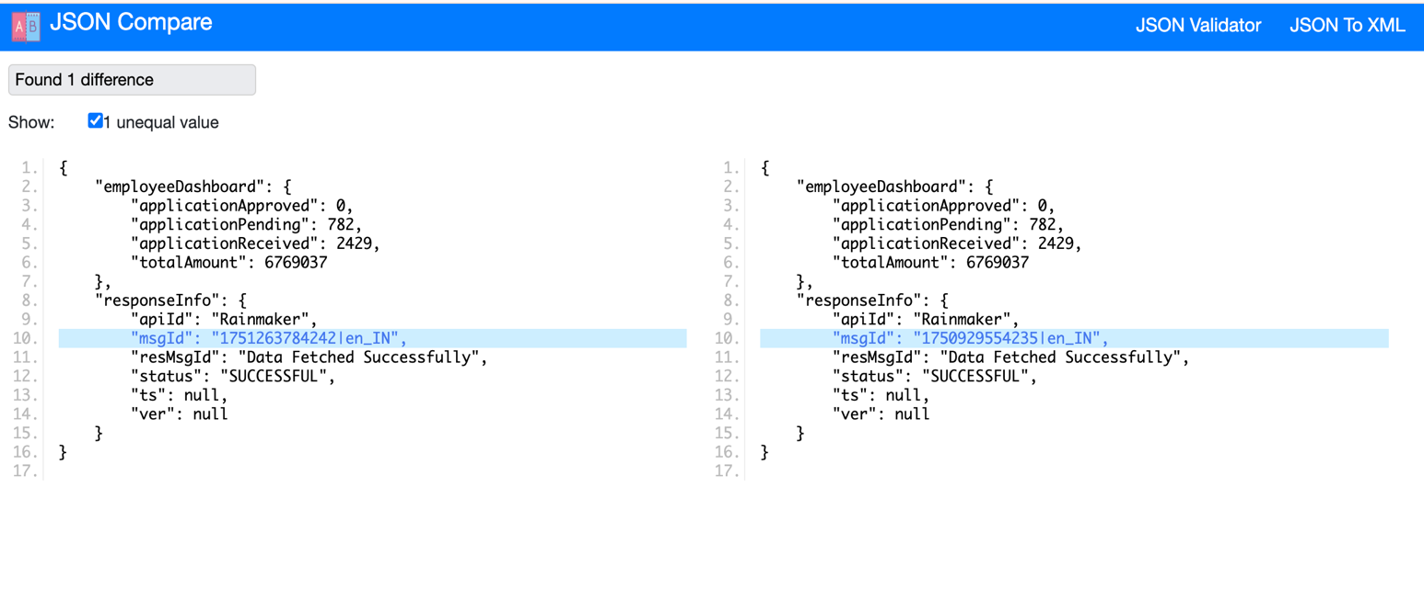

Supporting Evidence for OBPAS curl

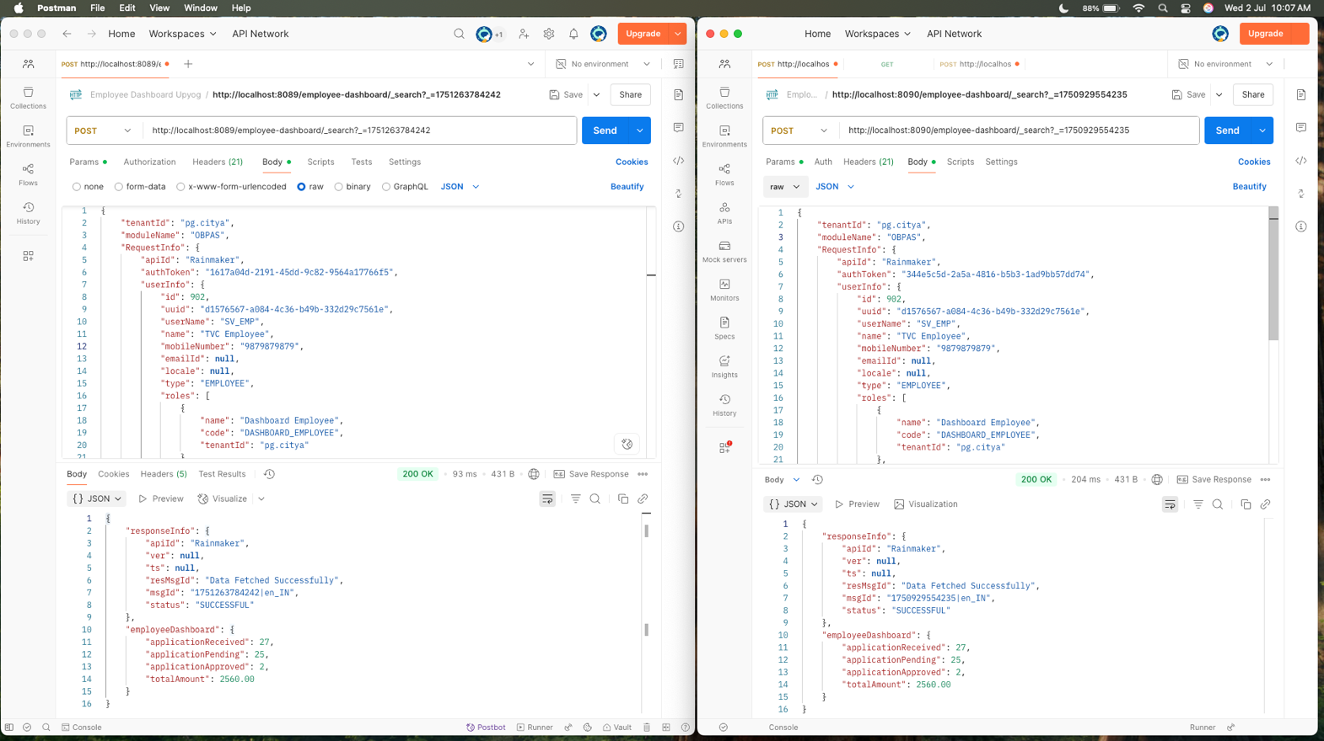

Response Difference of OBPAS

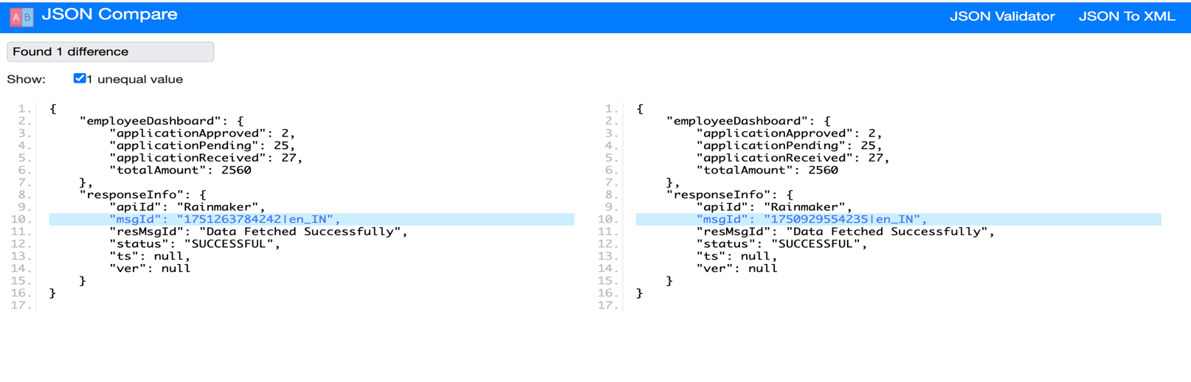

Supporting Evidence for ASSET curl

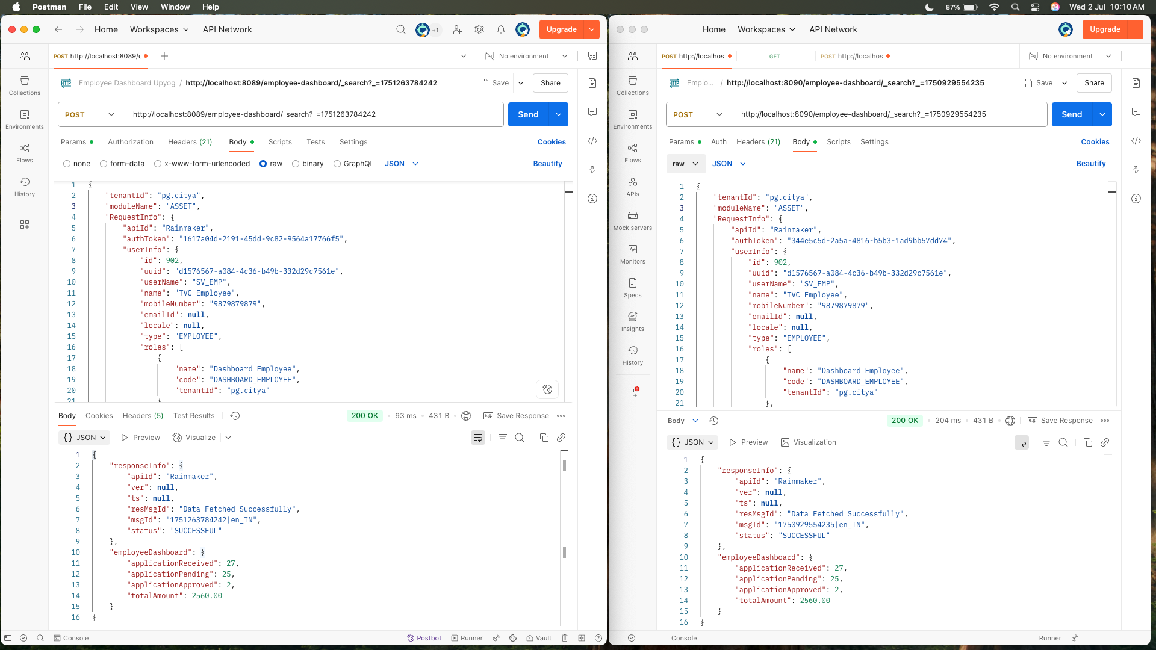

Response Difference of asset

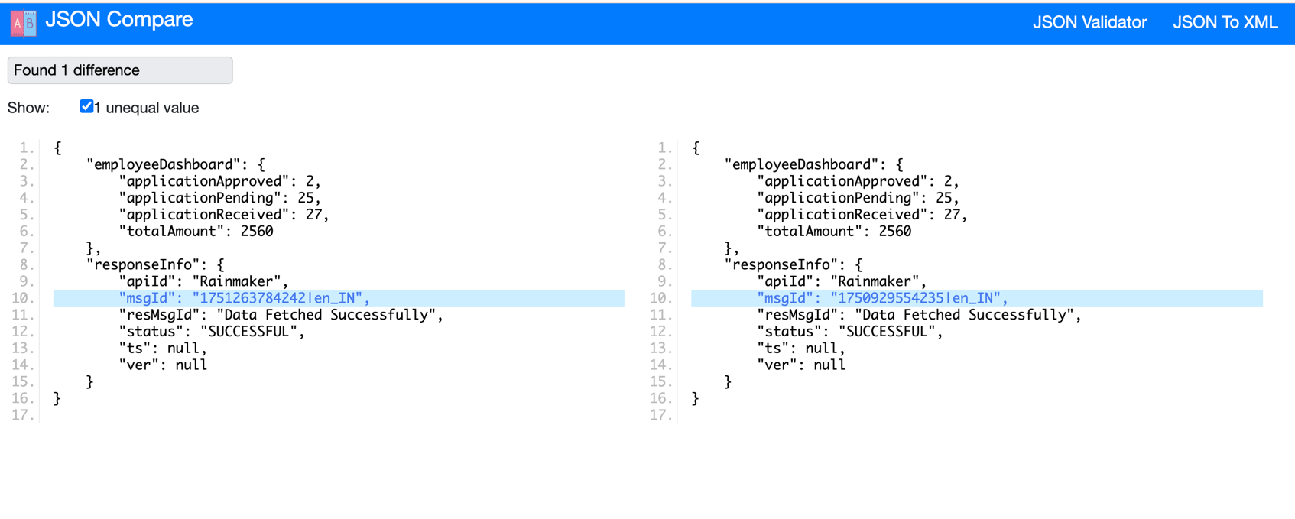

Supporting Evidence for FSM curl

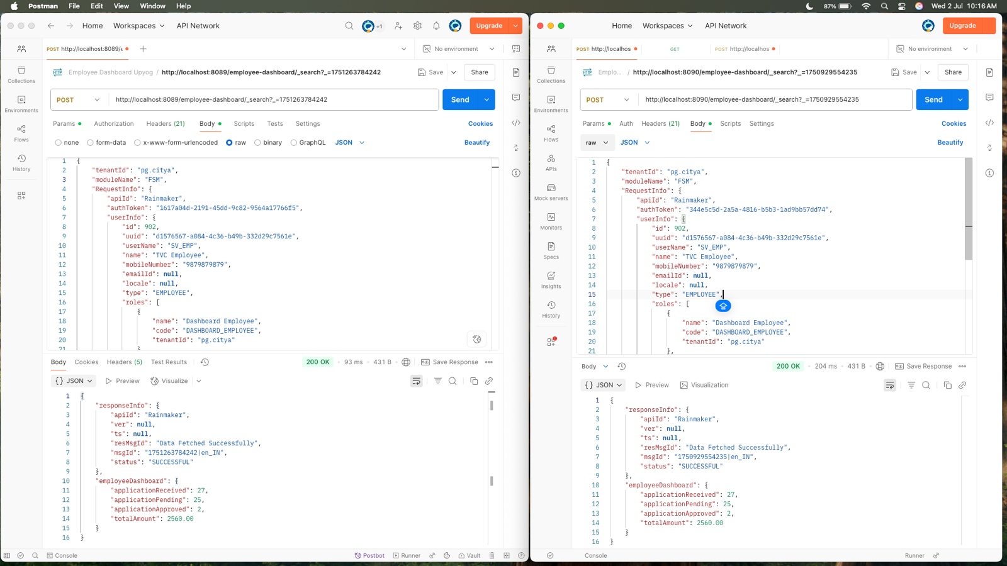

Response Difference of FSM

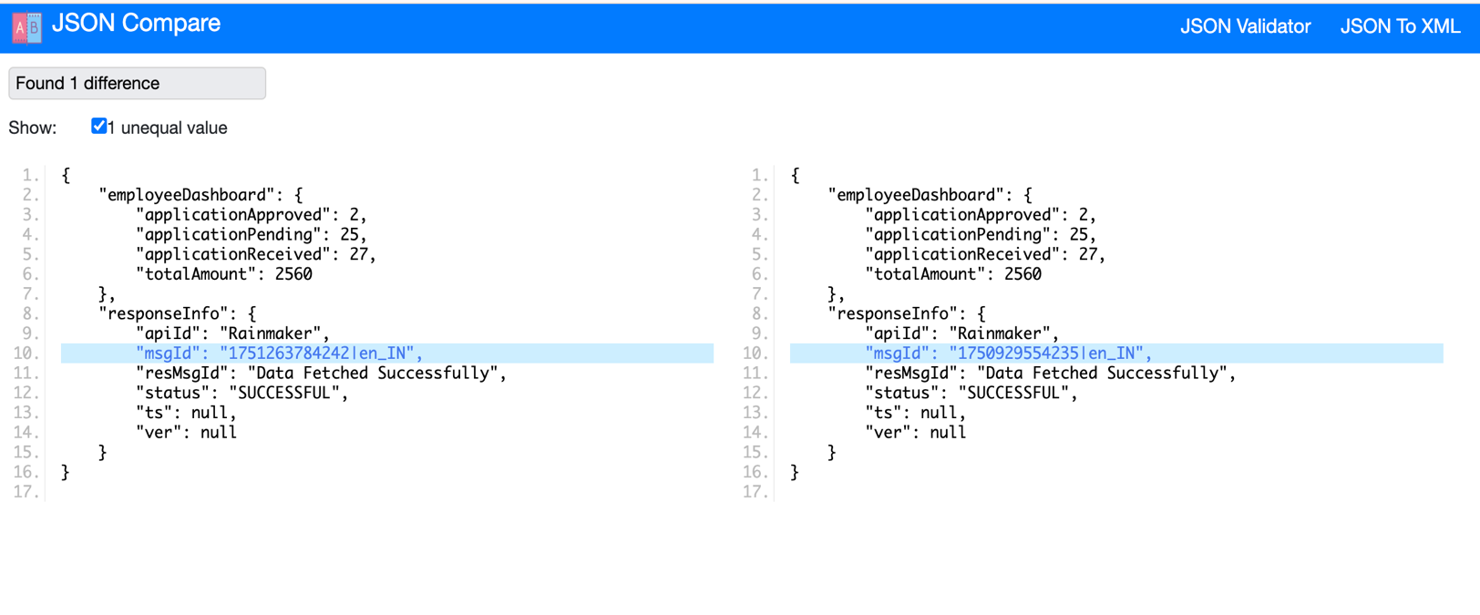

Supporting Evidence for PGR curl

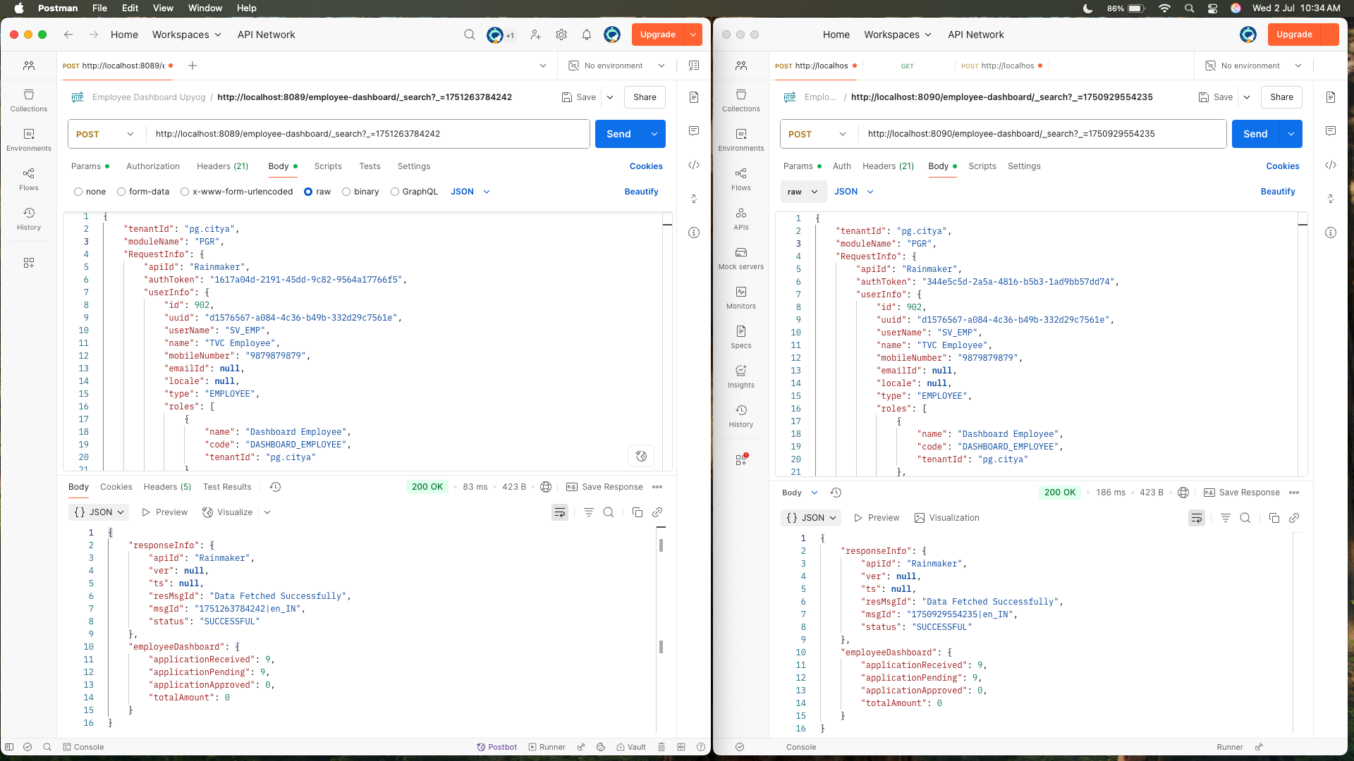

Response Difference of PGR

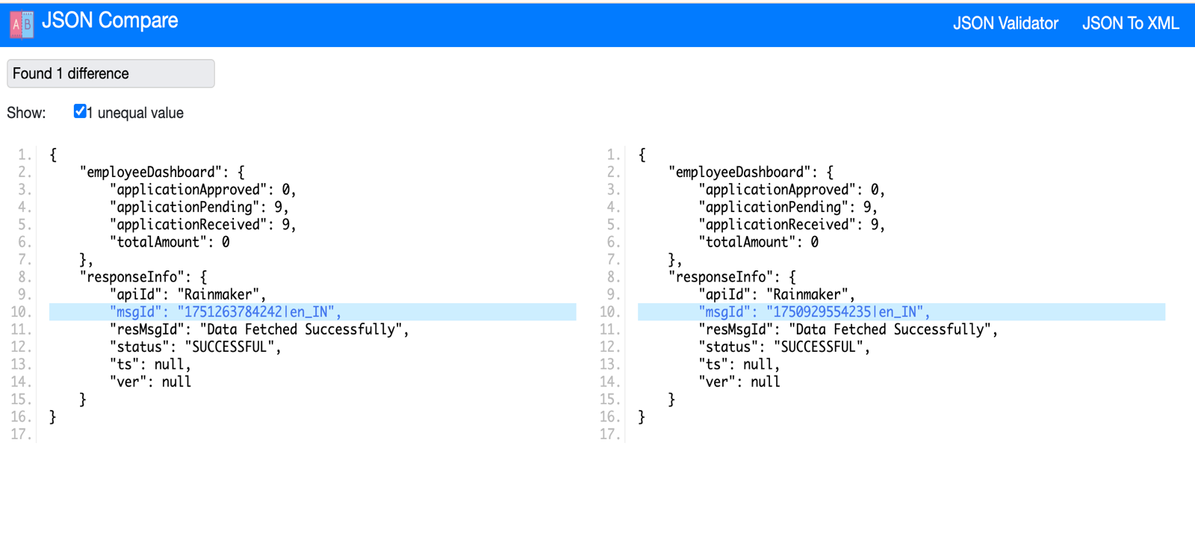

**Supporting Evidence for CHB curl**

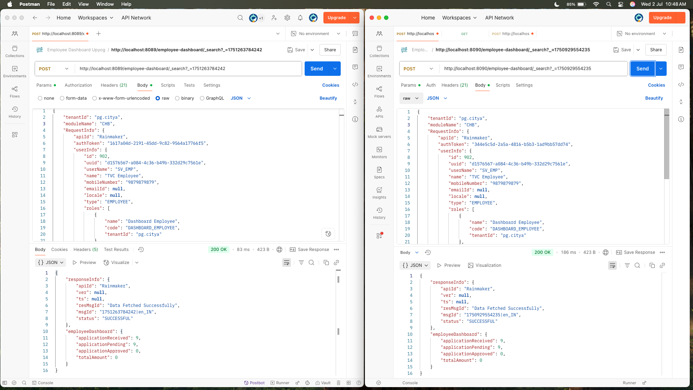

**Response Difference of CHB**

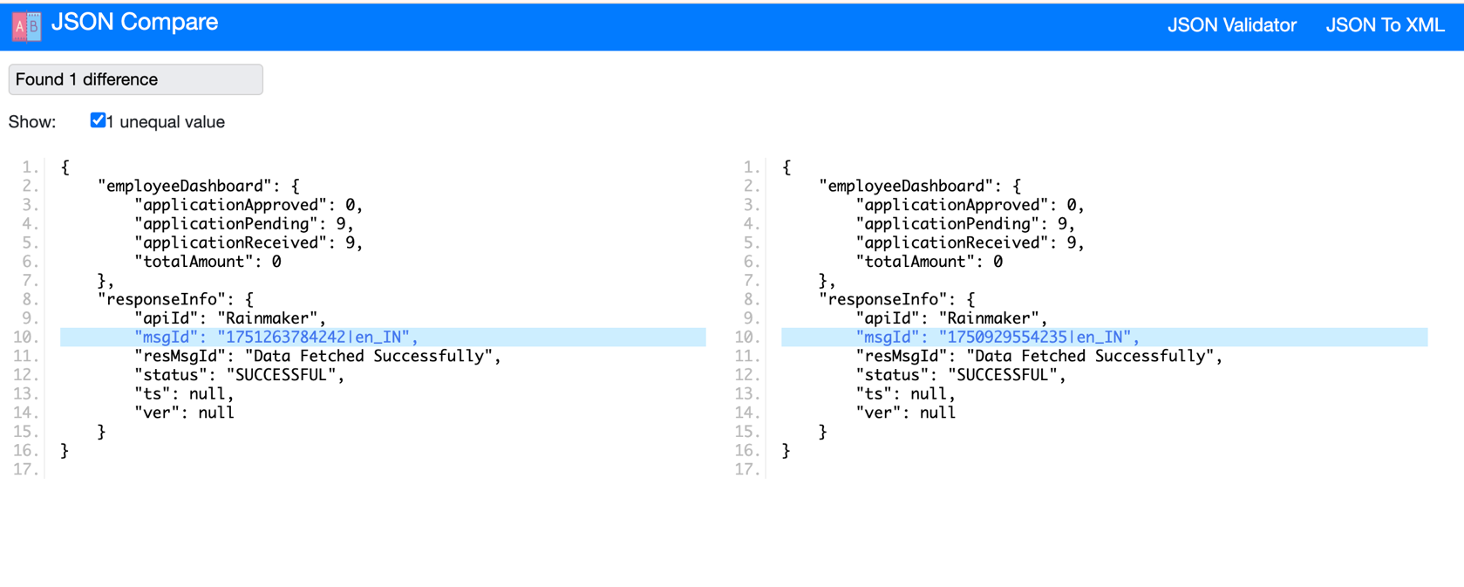

**Supporting Evidence for PT curl**

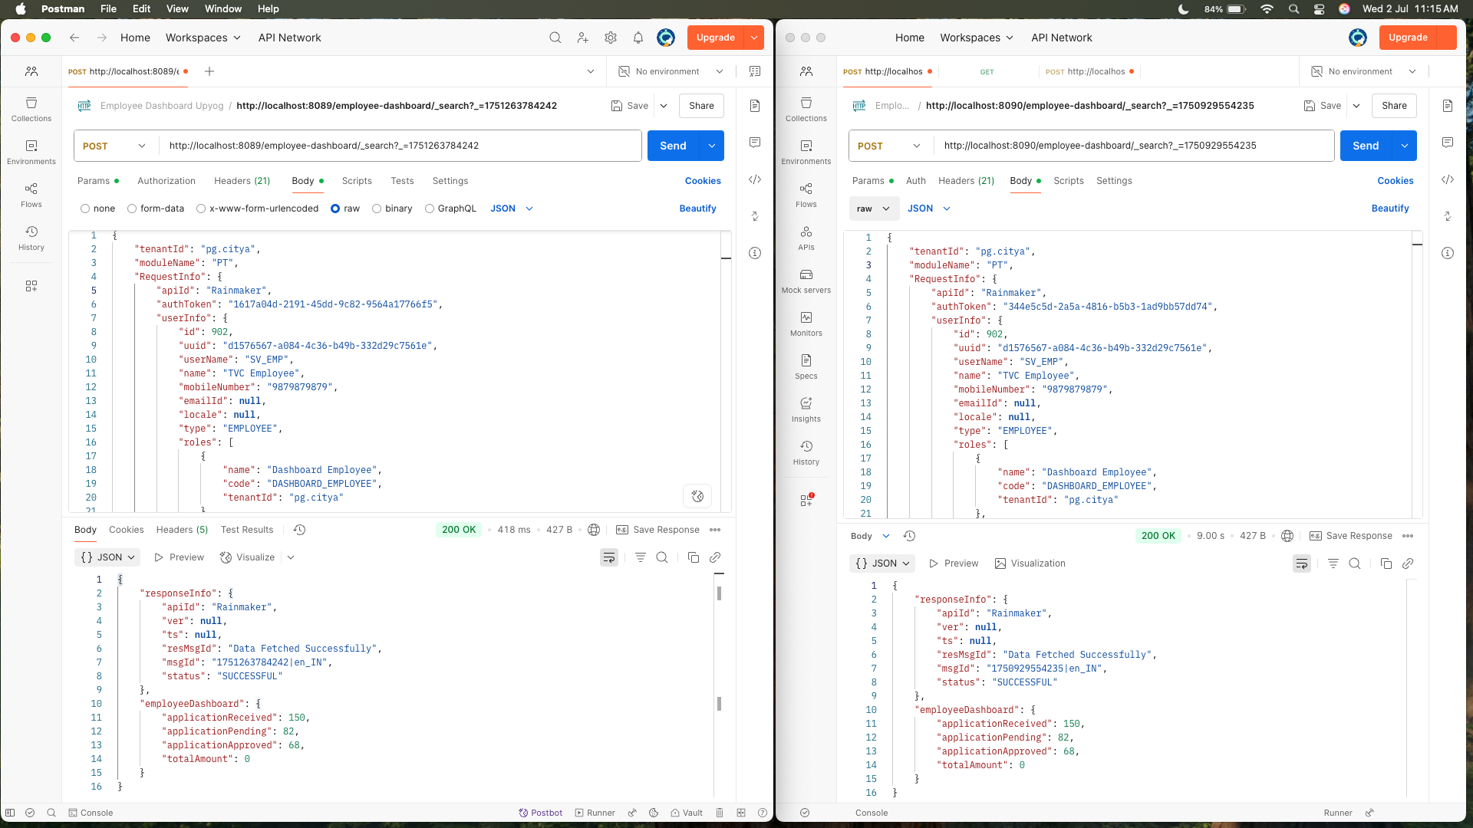

**Response Difference of PT**

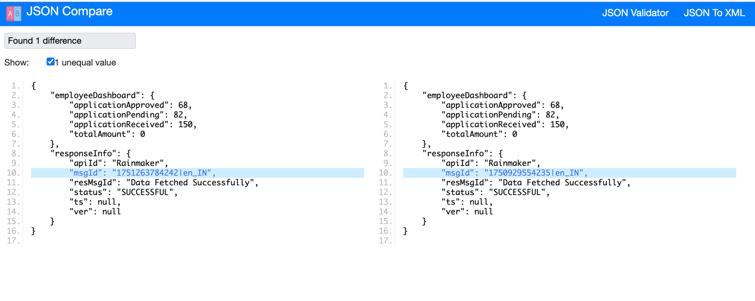

**Supporting Evidence for SEWERAGE curl**

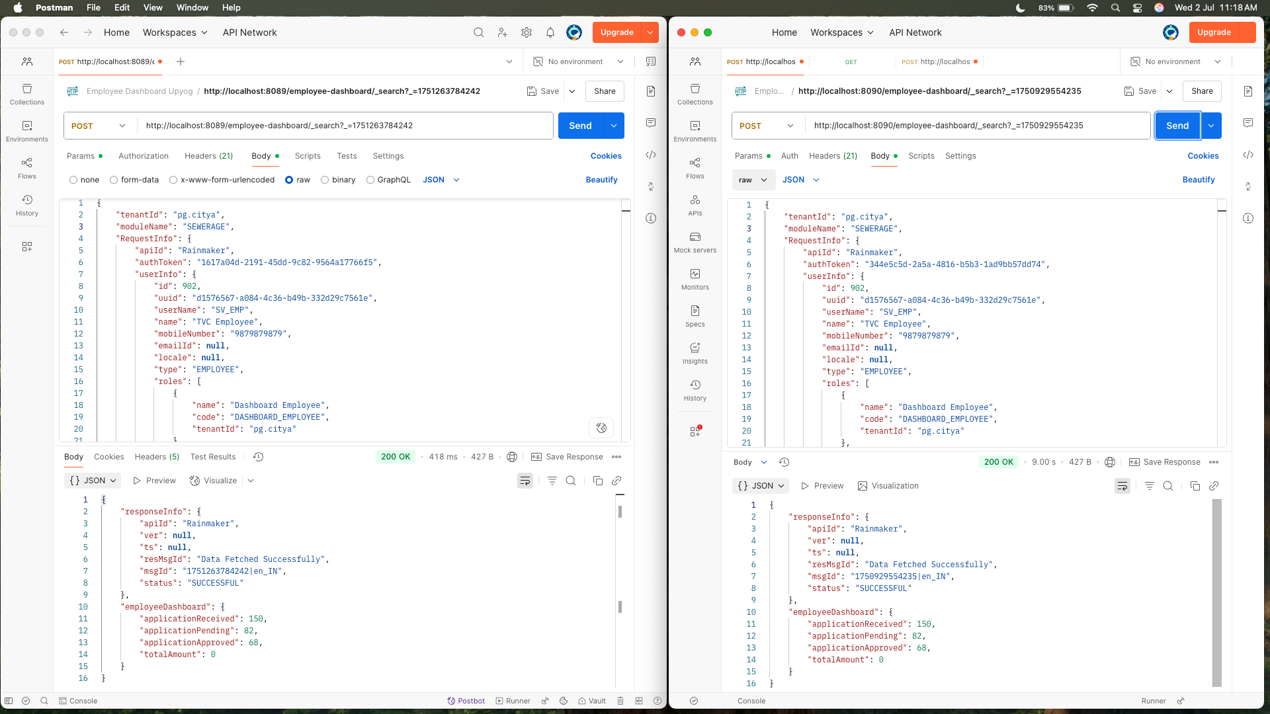

**Response Difference of SEWERAGE**



Supporting Evidence for PETSERVICES curl

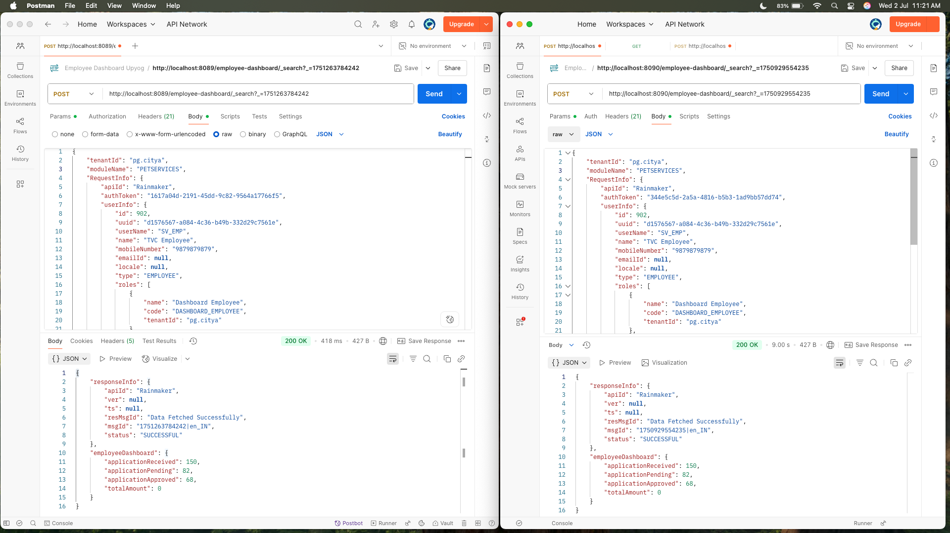

Response Difference of PETSERVICES

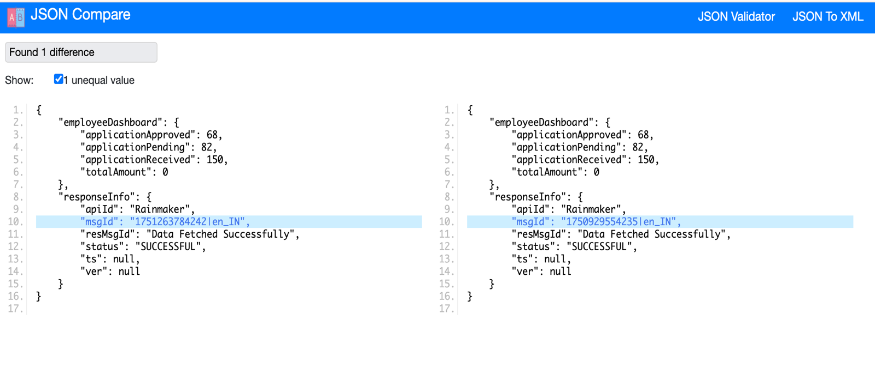

Supporting Evidence for TL curl

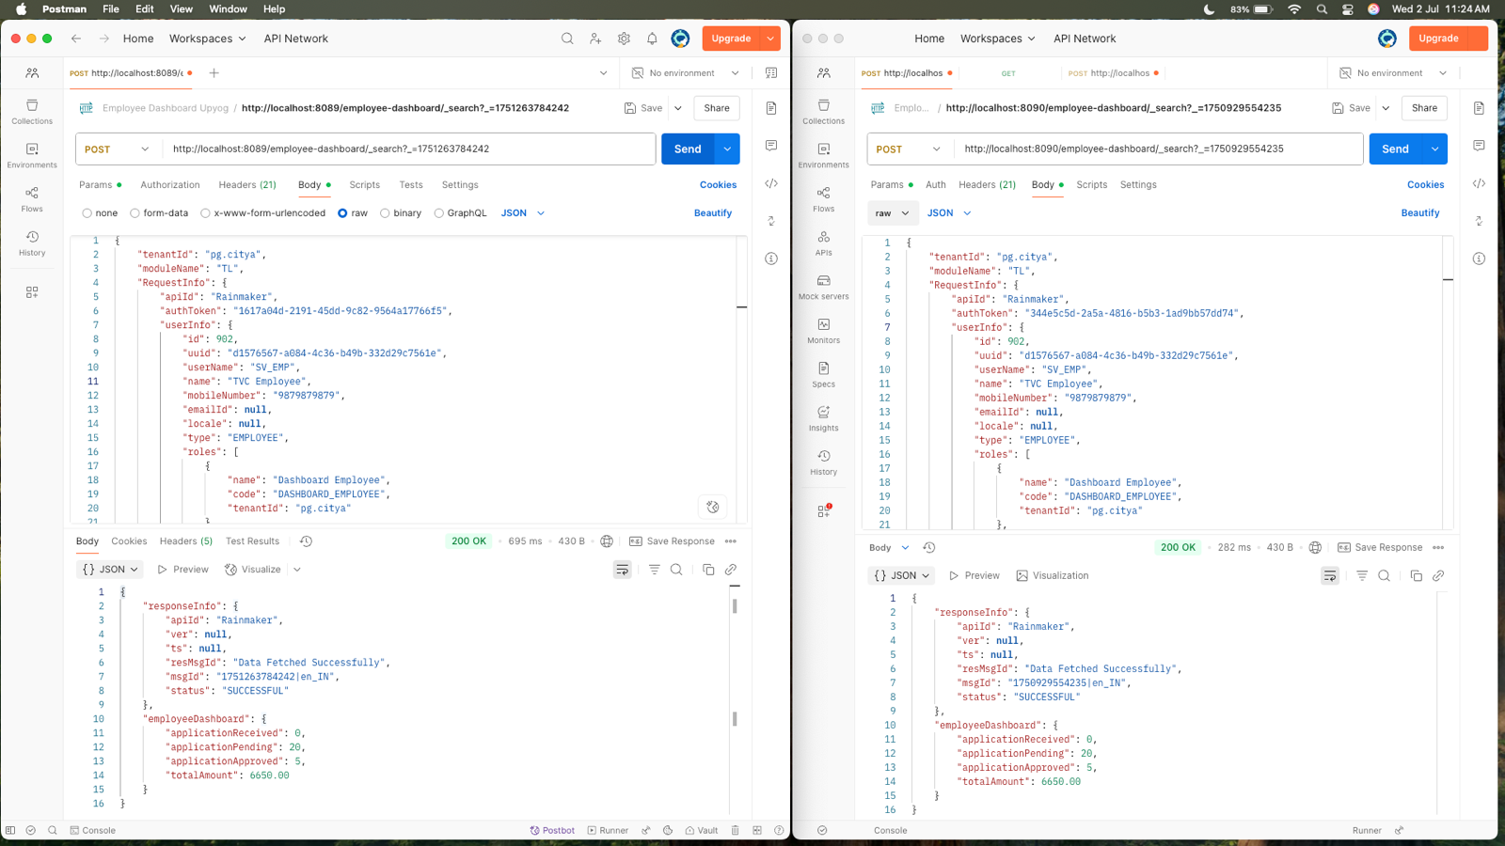

Response Difference of TL

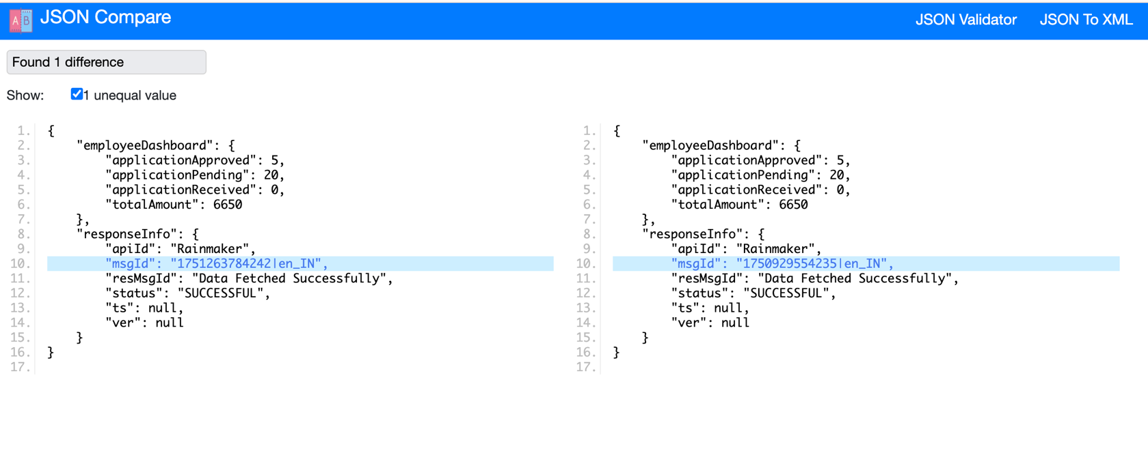

Supporting Evidence for WATER curl

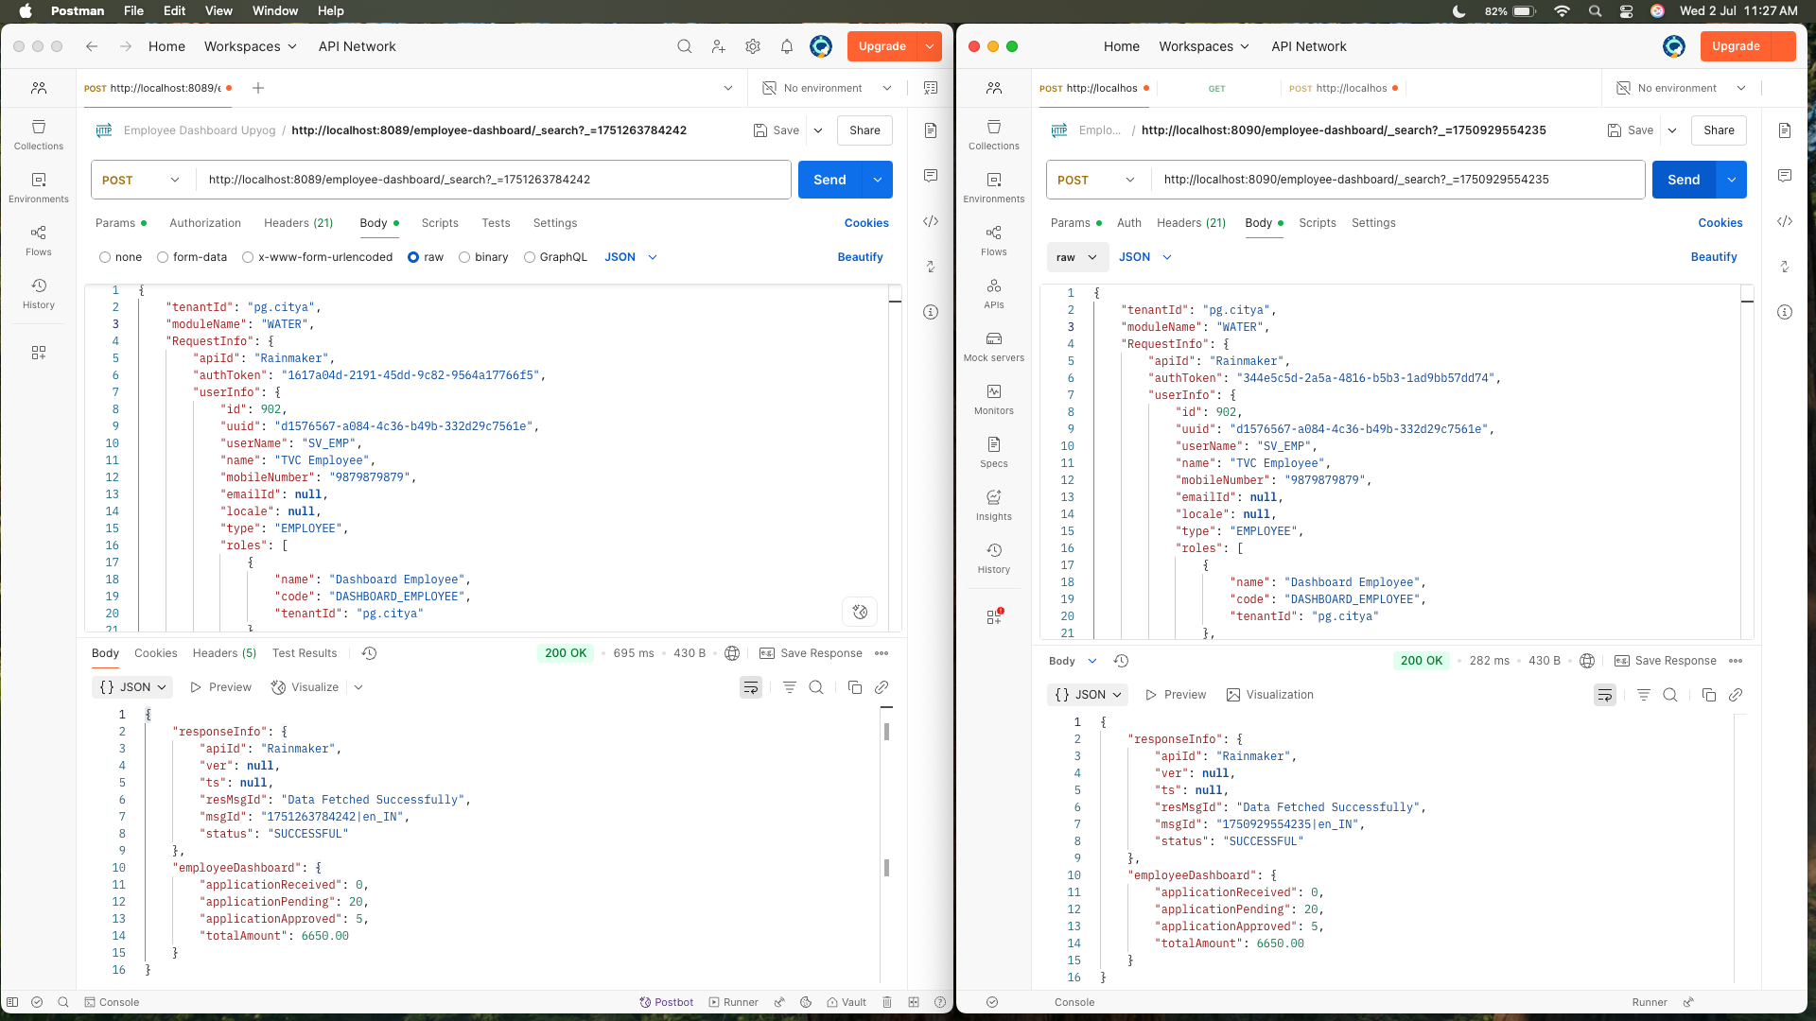

Response Difference of WATER

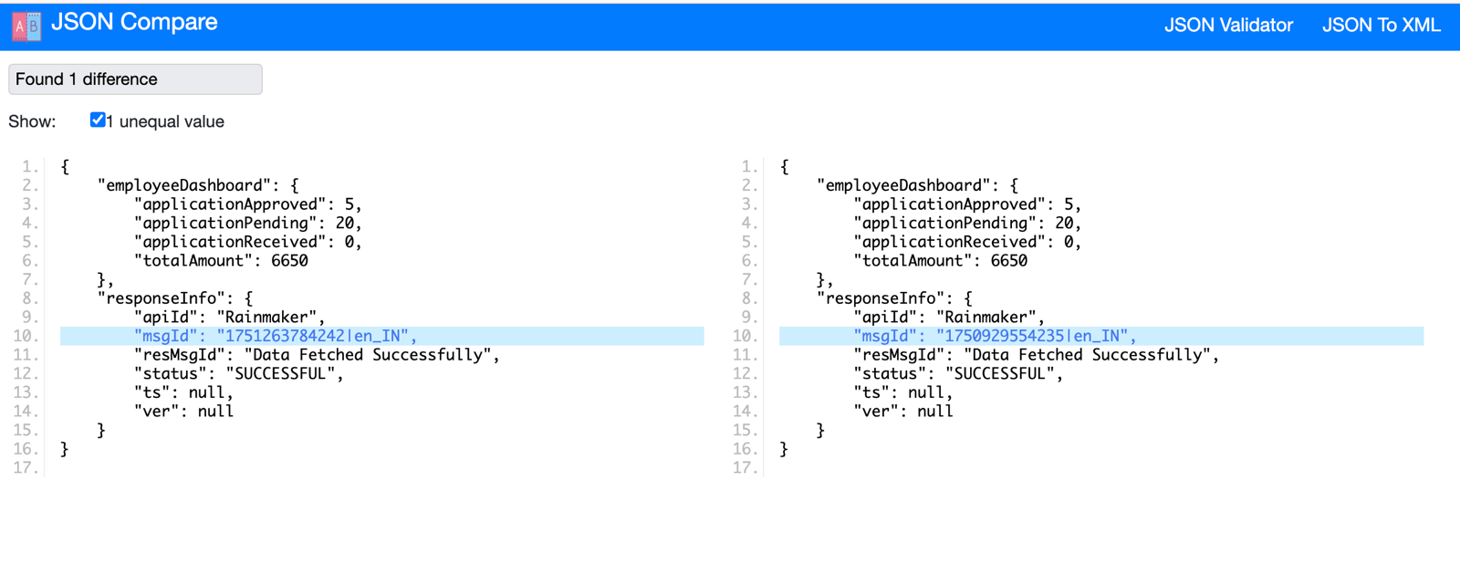

Supporting Evidence for EWASTE curl

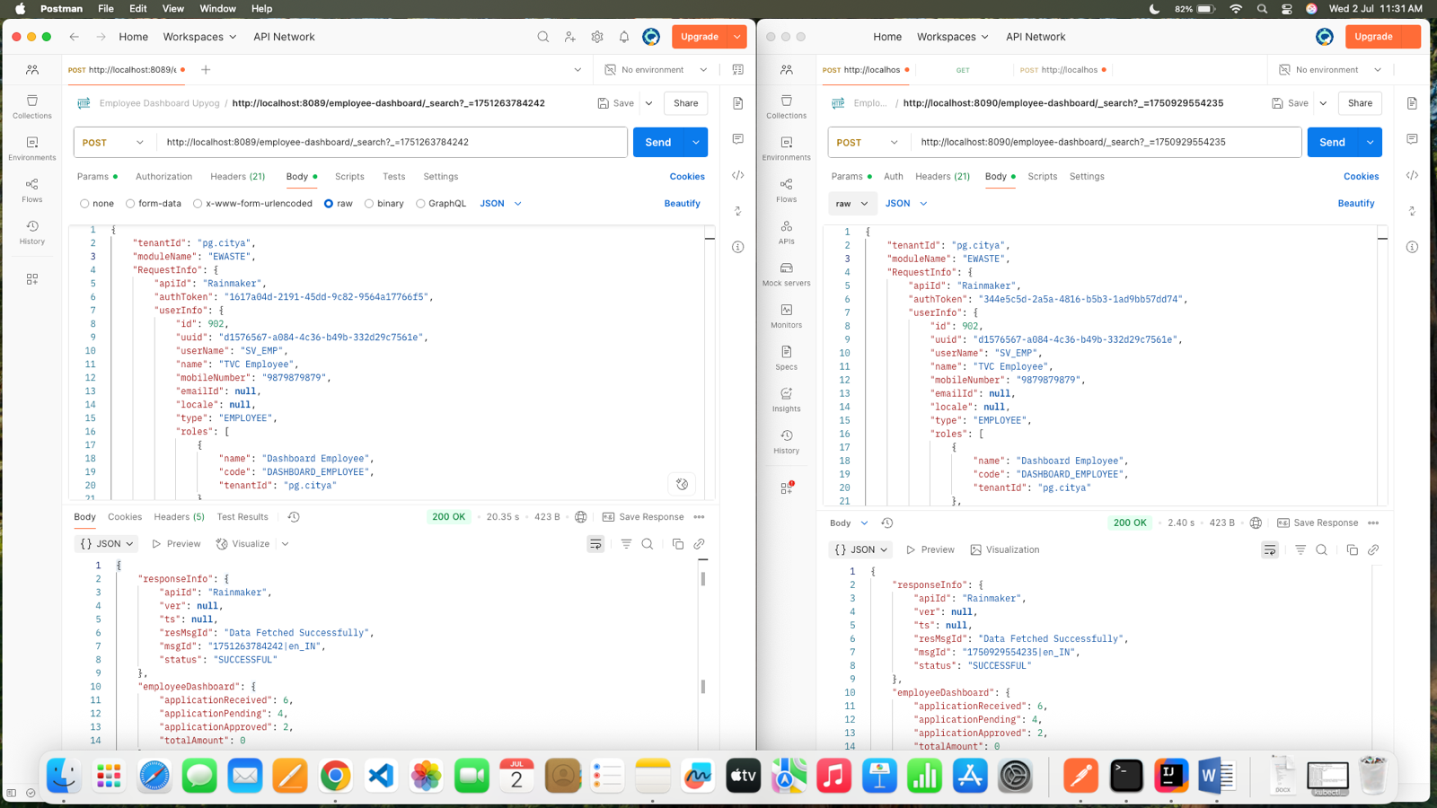

Response Difference of EWASTE

